Project 2: Final Cloud Deployment Architecture Plan

Matthew Santiago
University of Maryland Global Campus
CCS 630 Cloud Infrastructure Planning, Design, and Configurations
Alan Castillo
February 10, 2025

Executive Summary
In order to increase security, scalability, and reduce operating costs, BallotOnline has decided to initially migrate email, software development and backup/archiving to cloud infrastructure. In this report we examined 3 cloud providers for each of the services to migrate. The cloud provided were Amazon Web Services (AWS), Microsoft Azure and Google Cloud. In the end, we recommend AWS as the best cloud provider for BallotOnline based on performance, capacity, cost and availability. This paper describes the evaluation of cloud providers, proposed architecture of the cloud network, monitoring the cloud network, and limitations of the cloud environment.
Scope
This report describes the evaluations, architecture, monitoring and limitations of cloud providers as we prepare to move our applications to the cloud. It will guide the cloud ready applications to meet requirements for performance, capacity, cost and availability.
List of Approved 'Cloud Ready' Applications
- Email
- Software Development
- Backups/Archives
Evaluation of Cloud Service Offering Architecture for E-Mail
Throughout this transition to the cloud, BallotOnline needs to continually evaluate the different cloud providers to ensure we chose the best option for the company. In this review, we are evaluating the email services of the top cloud providers. Through our cloudy adoption and platform strategy, BallotOnline has determined that our email requirements will be a 15 minute recovery time objective (RTO), zero minute recovery point objective (RPO), 5,000 to 10,000 mailboxes and a fully managed and supported product by the vendor. Also, our email system has to have multifactor authentication, encryption and billing needs to be per user or mailbox monthly. We will be evaluating the cloud vendors on their performance, capacity, cost and availability.
Cloud Vendor | Performance | Capacity | Cost | Availability
Microsoft Outlook 365 | Internet required to install, activate and use email, management. Has desktop applications to work offline if internet is not available. (Microsoft, n.d.) | No min or max users listed. Determined per user added. Users get 100GB of storage per user. (Microsoft, n.d.) | $35.75 per user/month (Microsoft, n.d.) | Uptime SLA of 99.9% (Jha, 2013)
Google Gmail Enterprise | All internet based. Can run slow if network issues, too much filtering and labels (Google, n.d.). Has sending limits. (Google, n.d.) | No minimum or maximum user limit for Enterprise plans.  5 TB pooled storage. (Google, n.d.) | Must contact sales. (Google, n.d.) | Monthly Uptime Percentage will be at least 99.9% in any calendar month. (Google, 2025)
Amazon workmail | Ability to use Microsoft outlook application and existing corporate directory. (Amazon Web Services, n.d.) | No minimum/maximum users. 50 GB of mailbox storage for each user (Amazon Web Services, n.d.) | $4.00 per user per month (Amazon Web Services, n.d.) | Monthly uptime of 99.9% per SLA (Amazon Web Services, 2022)

After looking through the performance, capacity, cost, and availability data available from the cloud vendors, I propose that Amazon workmail be adopted for the email services of BallotOnline. It fully fulfills our 15-minute RTO and zero RPO needs, has strong security features, and integrates will all other Amazon Web Services products like Amazon SES and Microsoft outlook (Amazon Web Services, n.d.). Amazon SES enables “high-volume email automation” (Amazon Web Services, n.d.) for large scale email campaigns. Although, Microsoft 365 has proven recovery strategies and enterprise-oriented features that are in line with BallotOnline Goals. Amazon workmail integrates with other Amazon cloud options for seamless integration and can also be used with Microsoft outlook and mobile apps (Amazon Web Services, n.d.).
Evaluation of Cloud Service Offering Architecture for Software Development
Just as the section before, BallotOnline needs to continually evaluate the different cloud providers to ensure we chose the best option for the company. In this review, we are evaluating the software development environments of the top cloud providers. Through our cloud adoption and platform strategy, BallotOnline has determined that our software development environment requirements will be a zero min recovery time objective (RTO), 15 minute recovery point objective (RPO), 5,000 to 10,000 users, 1TB data storage per user, and 5000 to 15000 IOPS per user. Also, our software development environment has to have multifactor authentication, encryption and per month billing. We will be evaluating the cloud vendors on their performance, capacity, cost and availability.
Cloud Vendor | Performance | Capacity | Cost | Availability
AWS Elastic Beanstalk | “AWS Elastic Beanstalk uses proven AWS features and services, such as Amazon EC2, Amazon RDS, Elastic Load Balancing, Auto Scaling, Amazon S3, and Amazon SNS, to create an environment that runs your application” (Amazon Web Services, n.d.) This will keep performance high through use of these resources | This can be scaled for numbers of users from auto scaling. (Amazon Web Services, n.d.) | There is no additional charge for AWS Elastic Beanstalk. You pay for AWS resources (e.g. EC2 instances or S3 buckets) (Amazon Web Service, n.d.) | 99.99% uptime (Amazon Web Services, 2022)
Microsoft Azure App Service | Azure virtual machines have input/output operations per second (IOPS) and throughput performance limits based on the virtual machine type and size. (Microsoft, 2024) | Basic, Standard, and Premium service plans scale out to as many as 3, 10, and 30 instances. the Isolated tier further increase your scale-out count to 100 instances. (Microsoft, 2024) | Pay as you go - $281.78 per month for an instance with potential for dev discount (Microsoft, n.d.) | 99.99% uptime (Microsoft, 2024)
Google Cloud App Engine | IOPS are based on provisioned resource. You can change IOPS if needed every 4 hrs (Google, n.d.) | Google Cloud uses quotas to help ensure fairness and reduce spikes in resource use and availability. Increase available with pricing tier (Google, n.d.). | No specific pricing, just mentions “App Engine billing model such as standard environment instances, flexible environment instances, and App Engine APIs and services” (Google, n.d.) | 99.95% uptime (Google, 2020)
After looking through the performance, capacity, cost, and availability data available from the cloud vendors, I propose that Amazon Elastic Beanstalk be adopted for the software development environment for BallotOnline. It fulfills our zero minute RTO and 15 minute RPO needs, has strong security features, and integrates will all other Amazon Web Services products. Using AWS Elastic Beanstalk’s seamless deployment and scalability, our development teams will be able to deploy and maintain applications quickly and easily.
Evaluation of Cloud Service Offering Architecture for Backup and Archiving
Continuing the evaluation of cloudy ready applications we will consider cloud vendor offerings for Backups and Archiving. This evaluation is being done because BallotOnline needs to continually evaluate the different cloud providers to ensure we chose the best option for the company. In this review, we are evaluating the Backup and archiving environments of the top cloud providers. Through our cloud adoption and platform strategy, BallotOnline has determined that our Backup and archiving environment requirements will be a 30 min recovery time objective (RTO), 30 minute recovery point objective (RPO), 1 PB data storage, latency of 150ms, and 100 to 500 IOPS per user. Also, our Backup and archiving environment has to have multifactor authentication, encryption and per month billing. We will be evaluating the cloud vendors on their performance, capacity, cost and availability.
Cloud Vendor | Performance | Capacity | Cost | Availability
AWS S3 | Provide milliseconds latency and high throughput performance (AWS, n.d.) | Total data and objects is unlimited.  Individual instances max 5TB (AWS, n.d.) | Over 500 TB / Month$0.021 per GB (AWS, n.d.) | 99.9% uptime (Amazon Web Services, 2023)
Amazon Glacier | Frequent Access tier in 3—5 hours restore.  Deep Archive Access within 12 hours. (AWS, n.d.) | Not stated assumed to be unlimited as normal AWS S3 | Flexible Retrieval -All Storage / Month $0.0036 per GB  Deep Archive - All Storage / Month $0.00099 per GB  (AWS, n.d.) | 99.9% uptime (Amazon Web Services, 2023)
Azure Backup | Up to 24hours (Microsoft, 2024) | Maximum size of an individual data source is 54,400 GB. This limit doesn't apply to Azure VM backups. No limits apply to the total amount of data you can back up to the vault. (Microsoft, 2024) | geo-redundant storage (GRS) standard -$0.0448 per GB->  1PB/month=$473,520  Archive-$0.004 per GB -> 1PB/month=$1,285,269  (Microsoft, n.d.) | 99.9% uptime (Microsoft, 2024)
After looking through the performance, capacity, cost, and availability data available from the cloud vendors, I propose that Amazon S3 in combination with Amazon Glacier be adopted for the backup and archiving environment for BallotOnline. Combined it fulfills our needs, has strong security features, and integrates will all other Amazon Web Services products. Using AWS S3 and glaicer we will be able to back up and restore our systems both short term and long term easily.

Architecture Design for E-Mail in the Cloud
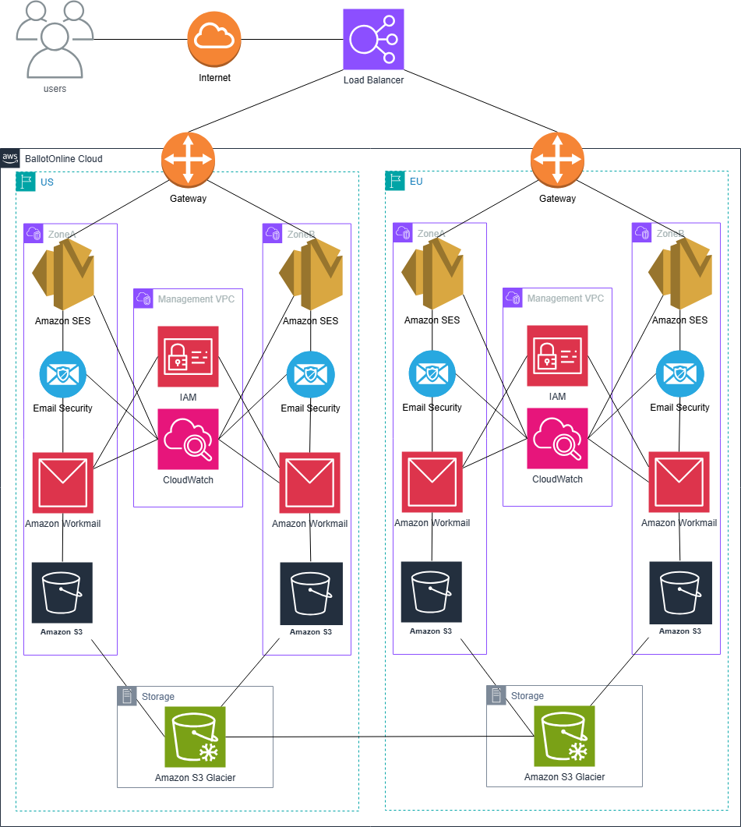

Architecture Design for Software Development Platform in the Cloud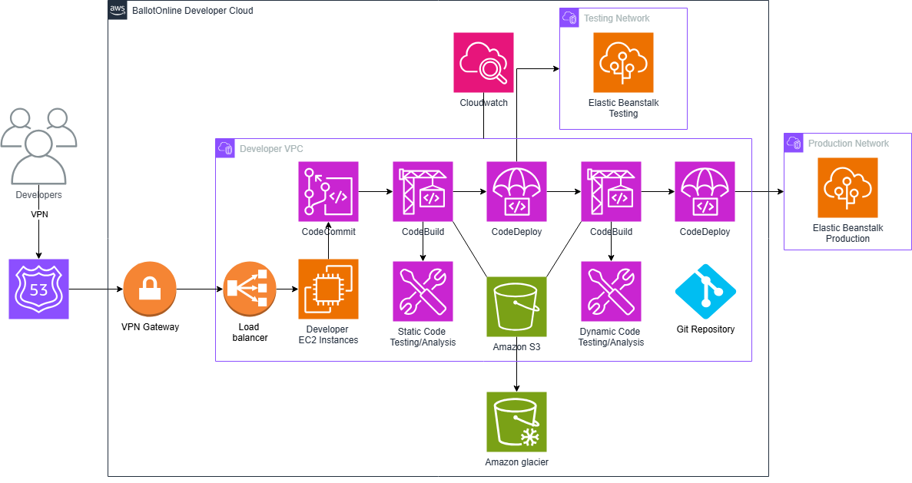Architecture Design for Backup and Archiving in the Cloud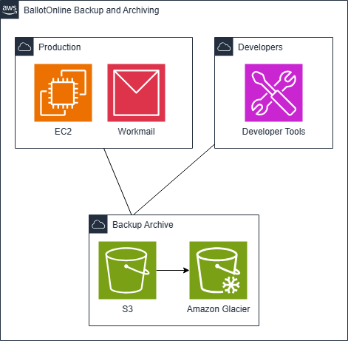
Cloud Monitoring Solution for Backup and Archiving
The need to monitor cloud resources is needed because it will allow BallotOnline to optimize costs and control of operations. AWS offers multiple tools, including, Amazon CloudWatch, AWS Billing and Cost Management Console, AWS Cost Explorer, AWS Budgets, AWS Trusted Advisor, and AWS Billing Alerts to help manage and optimize cost and control. These tools will help find of issues and metrics that could lead to increase in expenses and manage operations.
Amazon CloudWatch will keep track of key metrics such as storage utilization, instance metrics, and network utilization metrics. This is done by CloudWatch by "retrieves monitoring and operational data in the form of logs, metrics, and events" (Amazon Web Services, 2024). This will make sure administrators are informed whenever usage exceeds set limits to avoid unnecessary costs. The AWS Billing and Cost Management Console will give BallotOnline a clear view of costs by enabling cost tracking and forecasting, consolidated billing setup, and analysis of trends (Amazon Web Services, 2024). Also, AWS Cost Explorer can help enhance cost management by providing historical data analysis and future expense forecasting (Amazon Web Services, 2024).
AWS Budgets helps prevent budget overages by setting spending limits and sending notifications when those limits are about to be exceeded (Amazon Web Services, 2024). AWS Trusted Advisor will help us by providing recommendations on AWS best practices to optimize resources which in turn will help BallotOnline limit increased costs (Amazon Web Services, 2024). Lastly, AWS Billing Alerts which is found in CloudWatch will send notifications when the estimated costs are higher than the budgeted amount, so that measures can be taken to prevent costs from becoming too high (Amazon Web Services, 2024).
In conclusion AWS provides many tools that can be used to provide real time monitoring of our cloud resources and help ensure cost management and optimization. By using these tools BallotOnline will be able to control expenses while maintaining a robust cloud environment optimized for cost and user satisfaction. The AWS tools will not only help stop budget overages but enable effective executive decision making for long term operational and budget plans.
Limitations
Moving BallotOnline’s systems to the cloud is a definitely an important step in expanding the business but we need to cover some limitations we may encounter. AWS S3 and Amazon Glacier are not expense for storage and offer retrieval within minutes to hours. These 2 services work together to provide a wide coverage of our storage needs but they may not meet all of the recovery point requirements. Also, cloud storage may not be allowed for some jurisdictions and they may need that data to be stored securely in a local datacenter, which would increase costs. The software development environment could lead to the vendor lock in if our system requires certain proprietary cloud vendor tools to run. As we consider the pros to auto scaling, it is also pertinent to mention it could lead to unexpected cost if there are periods of high usage that was not planned for. Amazon WorkMail is affordable and has integration with Microsoft Outlook but does not include the collaboration tools that are available with Microsoft 365 and Google Workspace. The new cloud architecture will meet all of BallotOnline’s core requirements, but consideration of a few of these limitations is necessary for full decision making.
Summary
BallotOnline’s cloud migration strategy has been to improve security, scalability, and decrease cost while ensuring seamless integration into current operations. AWS is a powerful cloud environment which will be able to support our operations into the future. Using AWS monitoring tools such as AWS CloudWatch, AWS Budgets, and Cost Explorer we will be able to track the use of cloud resources and perform efficient cost analysis for the budget. There are limitations like vendor lock-in and possible regulatory problems with cloud adoption, these can be mitigated by AWS's global infrastructure and security controls. AWS infrastructure will put BallotOnline in a good position to take grow and deploy new technology quickly. By using AWS, BallotOnline can guarantee that our IT infrastructure will be adaptable to the needs of the business, security, and improve user experience.

References
Amazon Web Service. (n.d.). AWS Elastic Beanstalk Pricing. Retrieved from Amazon Web Service: https://aws.amazon.com/elasticbeanstalk/pricing/
Amazon Web Services. (2022, May 25). Amazon Compute Service Level Agreement. Retrieved from Amazon Web Services: https://aws.amazon.com/compute/sla/
Amazon Web Services. (2022, May 6). Amazon WorkMail Service Level Agreement. Retrieved from Amazon Web Services: https://aws.amazon.com/workmail/amazon-workmail-service-level-agreement/
Amazon Web Services. (2023, November 28). Amazon S3 Service Level Agreement. Retrieved from Amazon Web Services: https://aws.amazon.com/s3/sla/
Amazon Web Services. (2024). Amazon CloudWatch user guide. Retrieved from Amazon Web Services: https://docs.aws.amazon.com/pdfs/AmazonCloudWatch/latest/monitoring/acw-ug.pdf
Amazon Web Services. (2024). Analyzing your costs and usage with AWS Cost Explorer. Retrieved from Amazon Web Services: https://docs.aws.amazon.com/cost-management/latest/userguide/ce-what-is.html
Amazon Web Services. (2024). AWS Trusted Advisor. Retrieved from Amazon Web Services: https://docs.aws.amazon.com/awssupport/latest/user/trusted-advisor.html
Amazon Web Services. (2024). Managing your costs with AWS Budgets. Retrieved from Amazon Web Services: https://docs.aws.amazon.com/cost-management/latest/userguide/budgets-managing-costs.html
Amazon Web Services. (2024). What is AWS Billing and Cost Management? Retrieved from Amazon Web Services: https://docs.aws.amazon.com/awsaccountbilling/latest/aboutv2/billing-what-is.html
Amazon Web Services. (n.d.). Amazon WorkMail. Retrieved from Amazon Web Services: https://aws.amazon.com/workmail/
Amazon Web Services. (n.d.). Amazon WorkMail Pricing. Retrieved from Amazon Web Services: https://aws.amazon.com/workmail/pricing/
Amazon Web Services. (n.d.). Auto Scaling your Elastic Beanstalk environment instances. Retrieved from Amazon Web Services: https://docs.aws.amazon.com/elasticbeanstalk/latest/dg/using-features.managing.as.html
Amazon Web Services. (n.d.). AWS Elastic Beanstalk FAQs. Retrieved from Amazon Web Services: https://aws.amazon.com/elasticbeanstalk/faqs/
Amazon Web Services. (n.d.). Why Amazon SES? Retrieved from Amazon Web Services: https://aws.amazon.com/ses/
AWS. (n.d.). Amazon S3 FAQs. Retrieved from AWS: https://aws.amazon.com/s3/faqs/
AWS. (n.d.). Amazon S3 pricing. Retrieved from AWS: https://aws.amazon.com/s3/pricing/?nc=sn&loc=4
Google. (2020, January 30). App Engine Service Level Agreement (SLA). Retrieved from Google: https://cloud.google.com/appengine/sla?hl=en
Google. (2025, January 30). Google Workspace Service Level Agreement. Retrieved from Google: https://workspace.google.com/terms/sla/#
Google. (n.d.). Analyze the provisioned IOPS and throughput for Hyperdisk volumes. Retrieved from Google: https://cloud.google.com/compute/docs/disks/analyze-iops-hyperdisk
Google. (n.d.). App Engine. Retrieved from Google: https://cloud.google.com/appengine?hl=en#pricing
Google. (n.d.). Gmail sending limits in Google Workspace. Retrieved from Google: https://support.google.com/a/answer/166852?hl=en&ref_topic=7582322&sjid=12210061287976599873-NA
Google. (n.d.). Google Workspace. Retrieved from Google: https://workspace.google.com/pricing.html?source=gafb-enterprise-globalnav-en
Google. (n.d.). Quotas and limits . Retrieved from Google: https://cloud.google.com/appengine/docs/standard/quotas
Google. (n.d.). Troubleshoot slow performance in Gmail. Retrieved from Google: https://support.google.com/a/answer/2475607?hl=en&ref_topic=7582322&sjid=12210061287976599873-NA
Jha, R. (2013, August 8). Cloud services you can trust: Office 365 availability. Retrieved from Microsoft: https://www.microsoft.com/en-us/microsoft-365/blog/2013/08/08/cloud-services-you-can-trust-office-365-availability/
Microsoft. (2024, September 11). An overview of Azure VM backup. Retrieved from Microsoft: https://learn.microsoft.com/en-us/azure/backup/backup-azure-vms-introduction
Microsoft. (2024, September 12). Scale up an app in Azure App Service. Retrieved from Microsoft: https://learn.microsoft.com/en-us/azure/app-service/manage-scale-up
Microsoft. (2024, October 15). Service Level Agreements (SLA) for Online Services. Retrieved from Licensing Resources and Documents: https://www.microsoft.com/licensing/docs/view/Service-Level-Agreements-SLA-for-Online-Services?lang=1
Microsoft. (2024, December 30). Support matrix for Azure Backup. Retrieved from Microsoft: https://learn.microsoft.com/en-us/azure/backup/backup-support-matrix
Microsoft. (2024, December 10). Virtual machine and disk performance. Retrieved from Microsoft: https://learn.microsoft.com/en-us/azure/virtual-machines/disks-performance
Microsoft. (n.d.). App Service Environment plan. Retrieved from Microsoft: https://azure.microsoft.com/en-us/pricing/details/app-service/linux/
Microsoft. (n.d.). Azure Backup pricing. Retrieved from Microsoft: https://azure.microsoft.com/en-us/pricing/details/backup/#pricing
Microsoft. (n.d.). Office 365 E5 (no Teams). Retrieved from Microsoft: https://www.microsoft.com/en-us/microsoft-365/enterprise/office-365-e5?activetab=pivot:overviewtab

